CONTEXT DIAGRAM
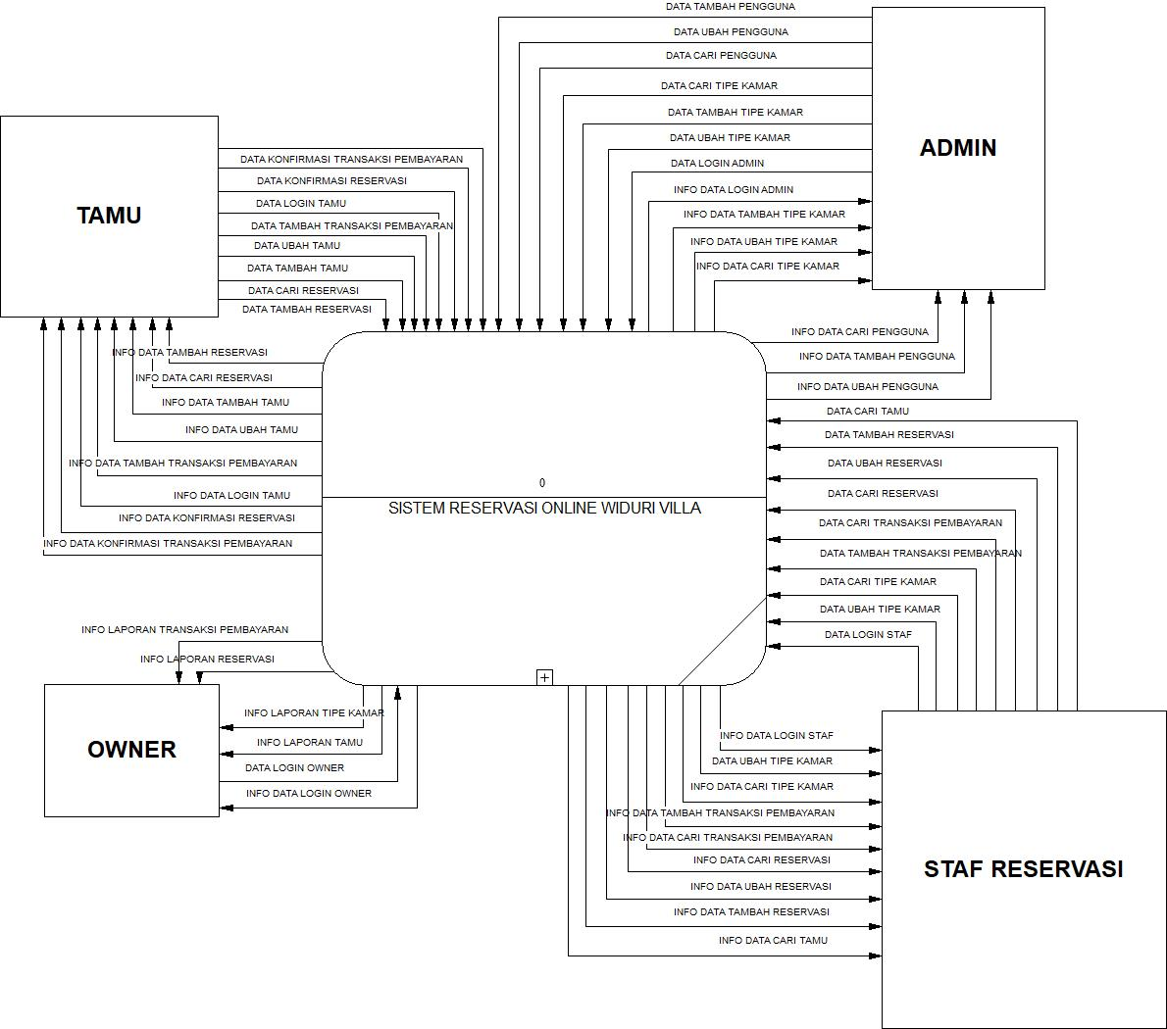
DFD LV 1
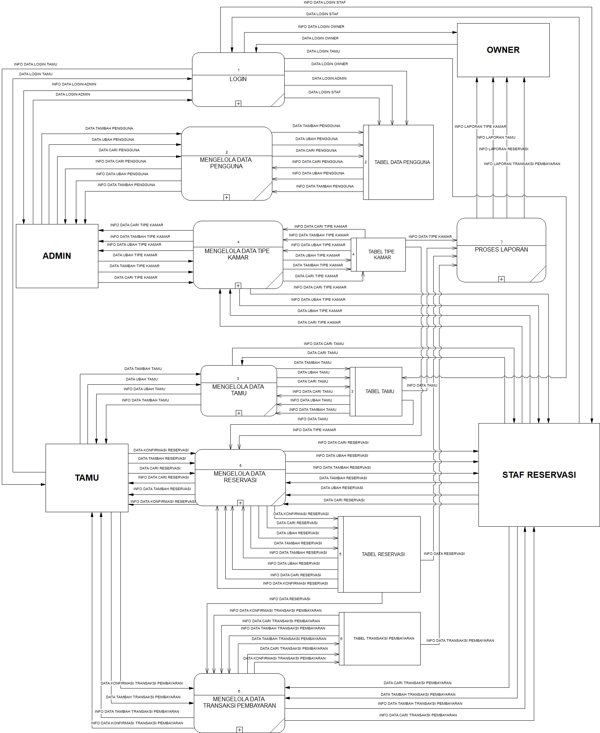

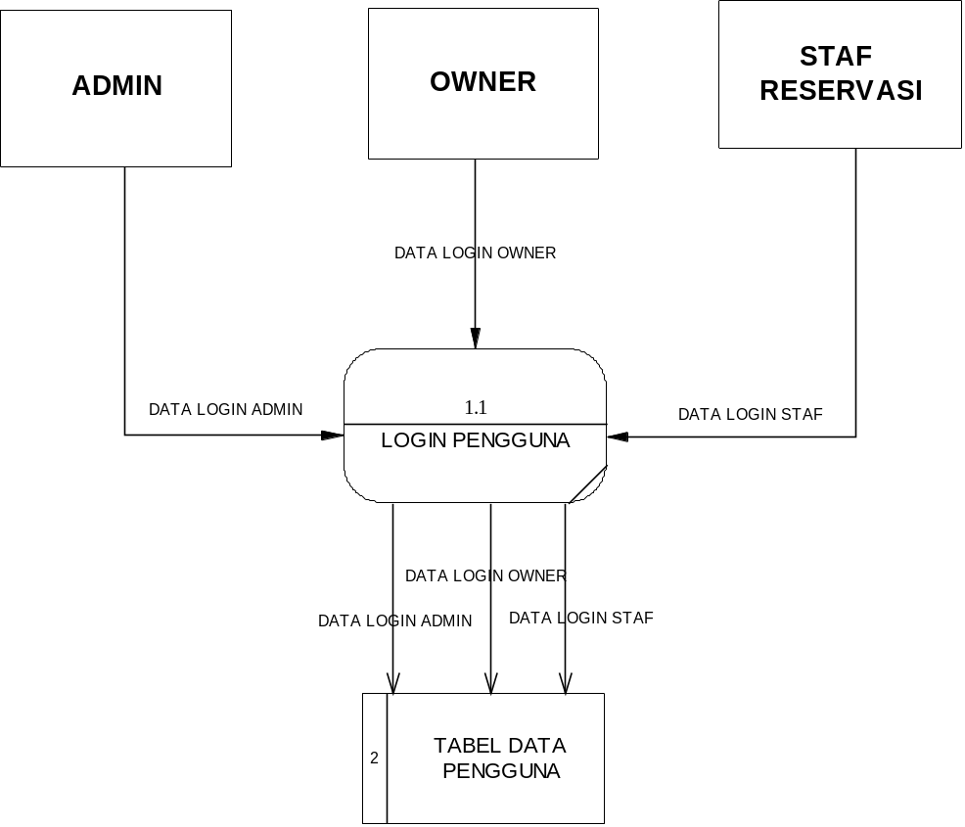
Data Flow Diagram Level 1 Login Pengguna
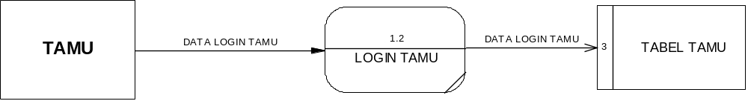
Data Flow Diagram Level 1 Login Tamu
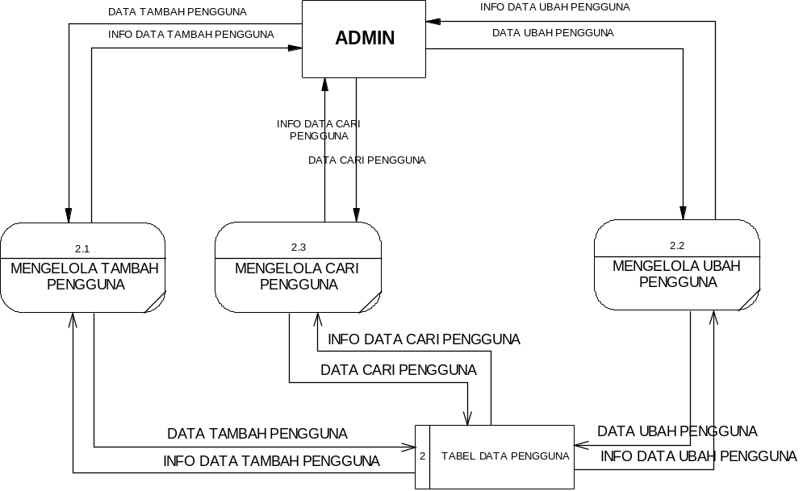
Data Flow Diagram Level 1 Data Pengguna
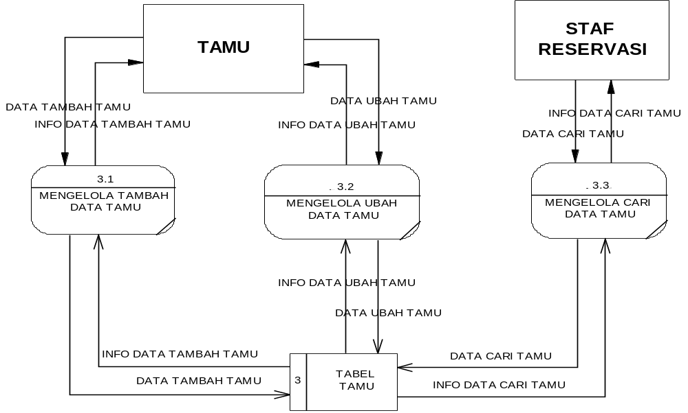
Data Flow Diagram Level 1 Data Tamu
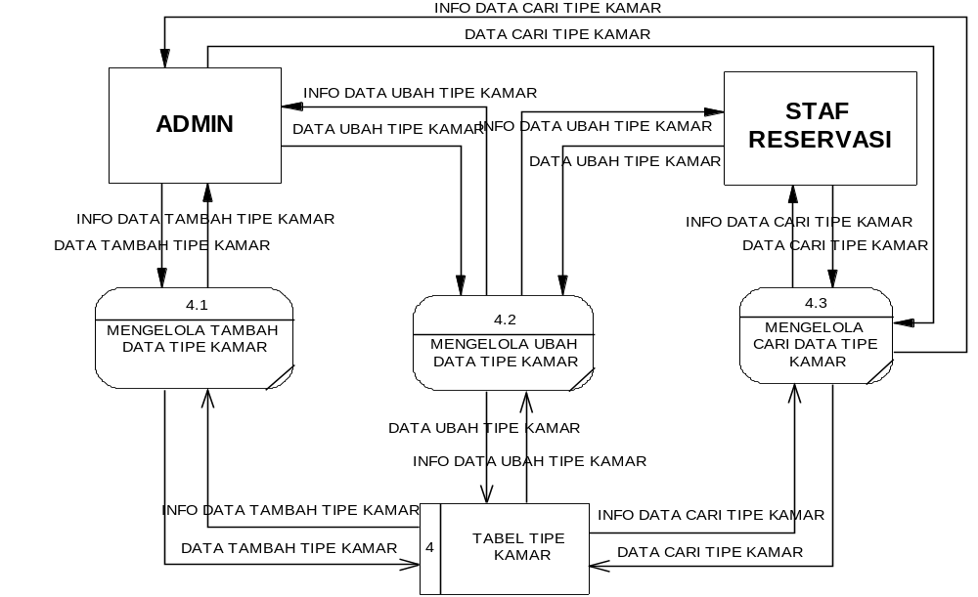
Data Flow Diagram Level 1 Data Tipe Kamar
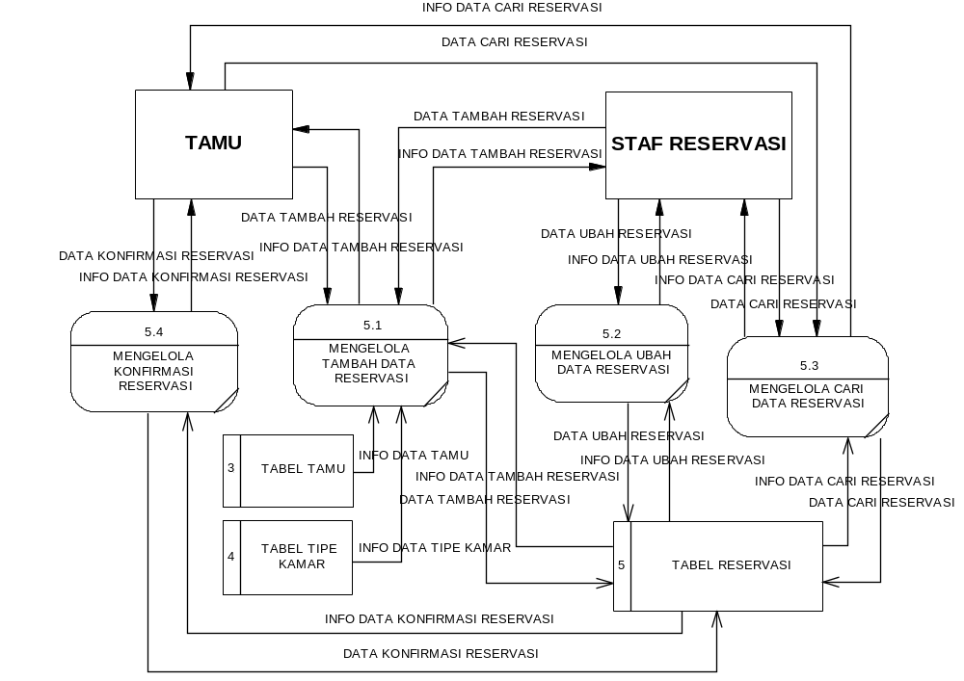
Data Flow Diagram Level 1 Data Reservasi
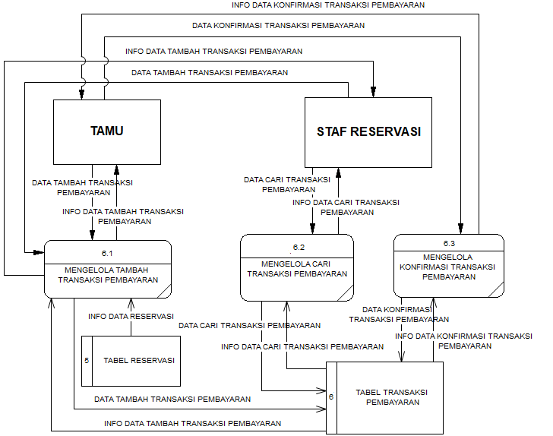
Data Flow Diagram Level 1 Data Transaksi Pembayaran
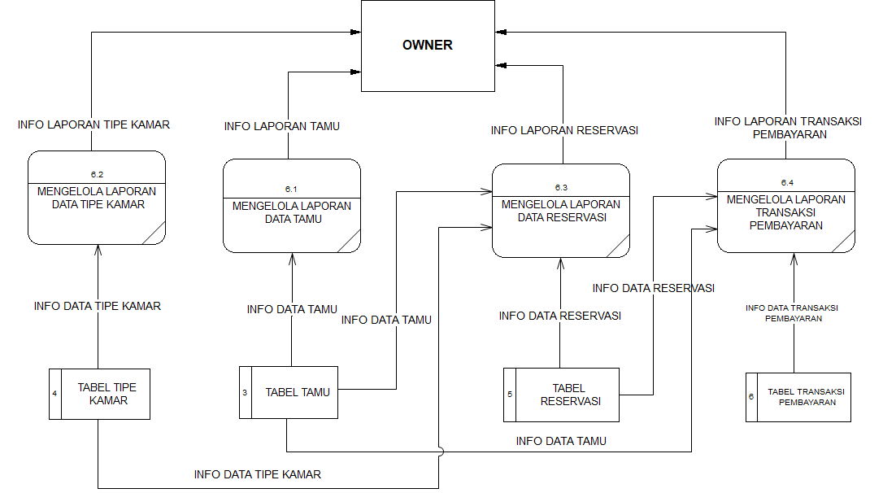
Data Flow Diagram Level 1 Laporan
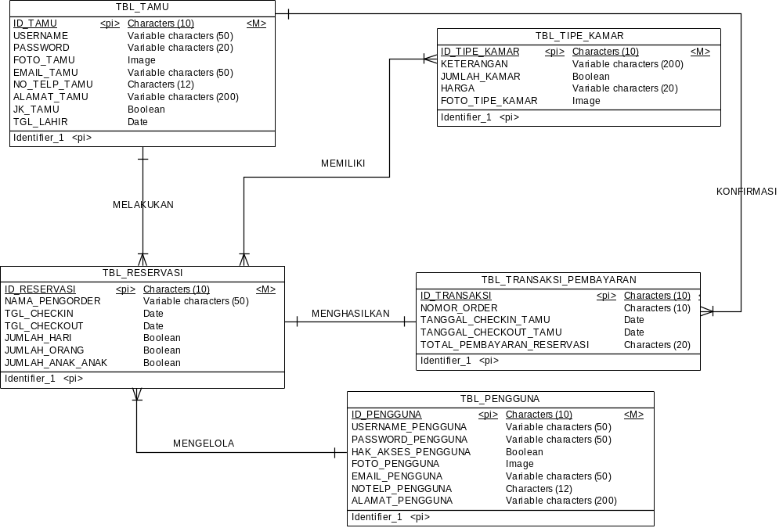
CDM
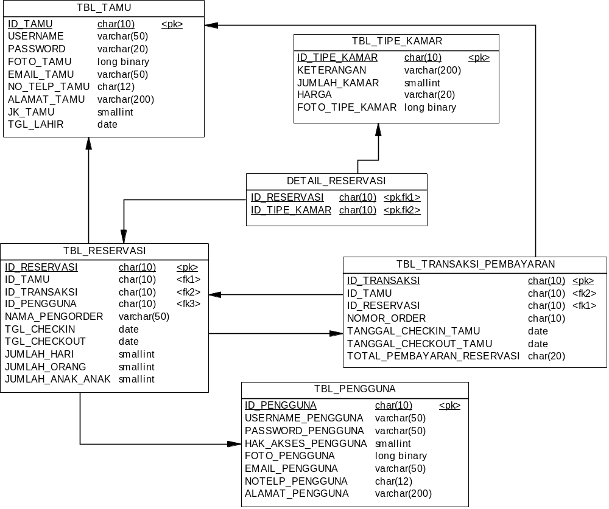
PDM

